AWS EC2 Windows RDP with Duo 2FA Implementation Guide

Executive Summary
This comprehensive guide demonstrates the implementation of multi-factor authentication (MFA) using Duo Security to secure Remote Desktop Protocol (RDP) access to AWS EC2 Windows Server instances. The project successfully integrates cloud infrastructure security with enterprise-grade authentication, providing a robust defense against unauthorized access while maintaining operational efficiency.

Architecture Overview
The solution combines three key components:
- AWS EC2 Windows Server 2019 - Cloud-hosted virtual machine
- Duo Security Platform - Third-party MFA service
- RDP with Duo Integration - Secured remote access protocol
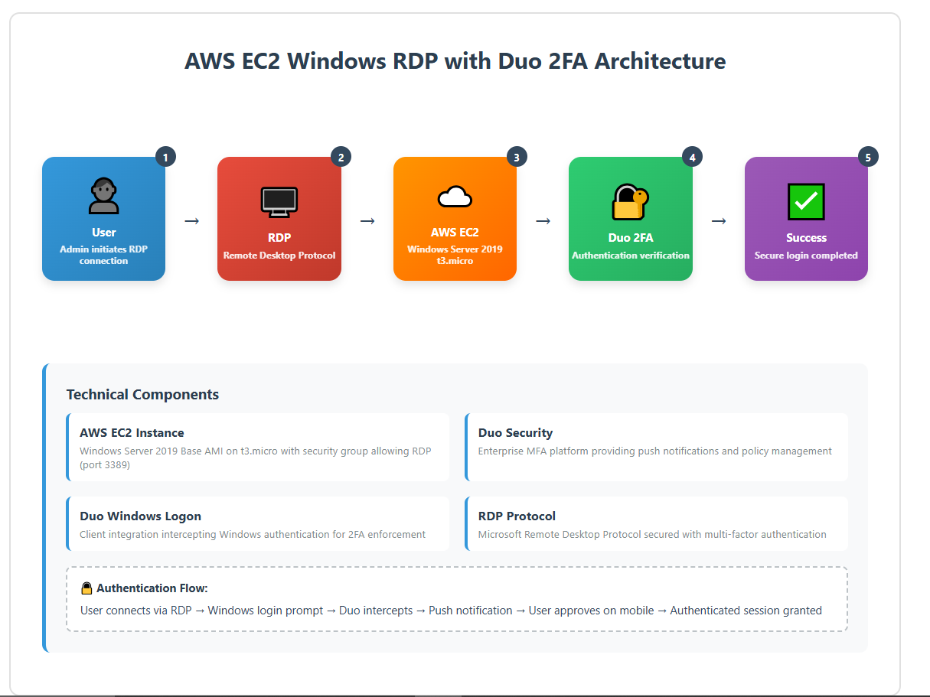
Figure 1: High-level architecture showing AWS EC2, Duo Security, and RDP integration

Prerequisites
- Active AWS account with EC2 service access
- Duo Security account (free trial available)
- Basic understanding of Windows Server administration
- RDP client software
- Mobile device for Duo Mobile app

Implementation Details

Phase 1: AWS EC2 Instance Setup

Instance Configuration
- AMI: Microsoft Windows Server 2019 Base
- Instance Type: t2.micro (Free Tier eligible)
- Region: Configured for optimal performance
- Storage: Default EBS configuration
- Key Pair: Created for initial access

Security Group Configuration
The security group must allow inbound RDP traffic:
Protocol | Port | Source | Description
TCP | 3389 | 0.0.0.0/0 | RDP Access (restrict to specific IPs in production)
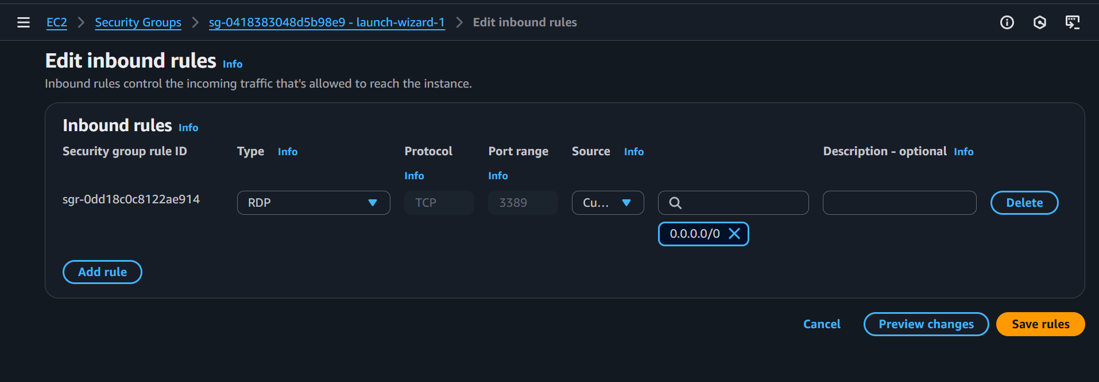
Figure 2: AWS EC2 Security Group inbound rules configuration showing RDP access on port 3389
Security Note: In production environments, restrict RDP access to specific IP ranges rather than allowing global access (0.0.0.0/0).

Phase 2: Duo Security Setup

Application Registration
- Created Microsoft RDP application in Duo Admin Portal
- Generated integration credentials:
  - Integration Key
  - Secret Key
  - API Hostname

User Management
- Created user accounts matching Windows usernames (e.g., "administrator")
- Configured user groups for access control
- Established group-based permission policies

Phase 3: Duo Client Installation

Installation Process
The Duo Authentication for Windows Logon client(https://duo.com/docs/rdp) was installed directly on the EC2 instance via RDP session. The installation wizard requires:
- Integration Key from Duo Admin Portal
- Secret Key for secure communication
- API Hostname for service connectivity
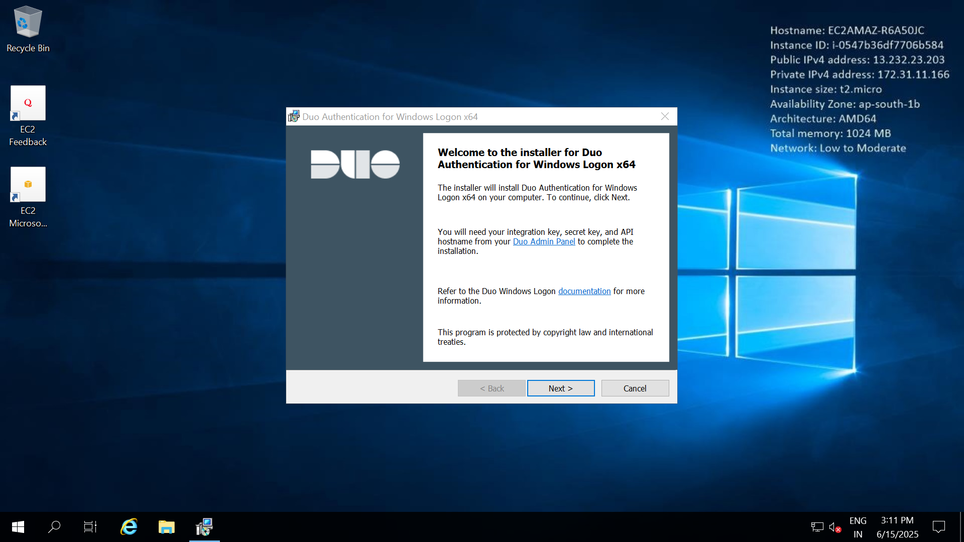
Figure 3: Duo Authentication for Windows Logon x64 installer welcome screen on AWS EC2 Windows Server 2019

Configuration Requirements
- Client must be configured before first 2FA-enabled login attempt
- Backup access methods should be established before enabling MFA
- Service account considerations for automated processes

Authentication Flow

Standard Login Process
- User initiates RDP connection to EC2 instance
- Windows login prompt appears
- User enters username and password
- Duo intercepts authentication request
- Duo sends push notification to registered mobile device
- User approves/denies authentication on mobile app
- Upon approval, Windows completes login process
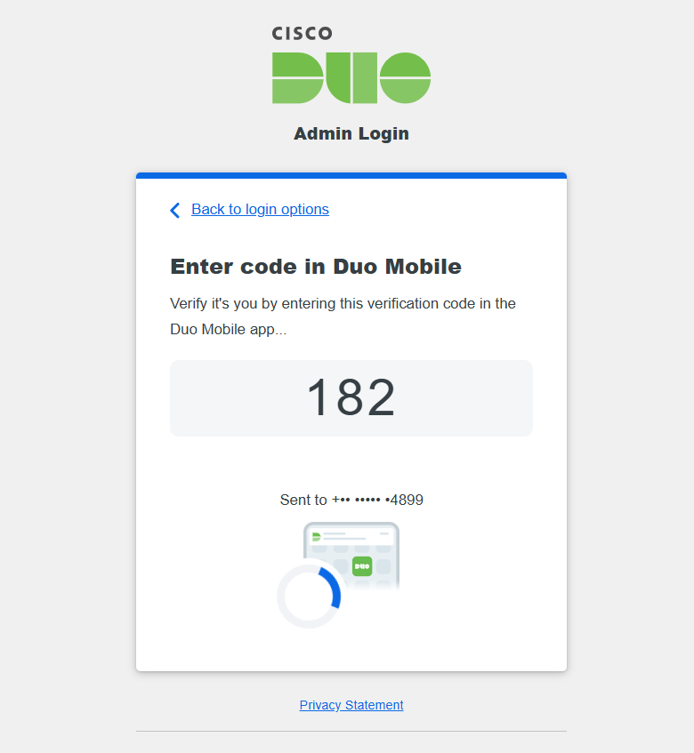
Figure 4: Duo Mobile verification screen showing 6-digit code (182) for admin login authentication
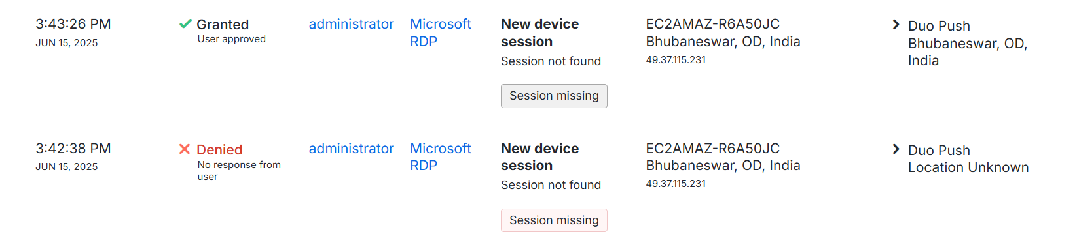
Figure 5: Duo Admin Portal showing authentication attempts - successful grant and denied access for administrator user

Alternative Authentication Methods
- SMS Codes: Fallback option when push notifications unavailable
- Phone Calls: Voice-based verification for device-less scenarios
- Hardware Tokens: For high-security environments
- Bypass Codes: Emergency access when primary methods fail

Troubleshooting Guide

Common Issues and Solutions

"User not in permitted group" Error
Symptoms: Authentication fails despite correct credentials.
Root Cause: Duo application policy restricts access to specific groups.
Resolution:
- Verify user group membership in Duo Admin Portal
- Update application settings to include appropriate groups
- Ensure group names match exactly (case-sensitive)

Instance Type Limitations
Symptoms: Cannot launch desired instance type.
Root Cause: T2 Unlimited restrictions in certain regions.
Resolution: Switch to t3.micro instance type in supported regions

Authentication Timeout
Symptoms: Login process hangs or times out.
Root Cause: Network connectivity or API configuration issues.
Resolution:
- Verify API hostname configuration
- Check security group rules for outbound HTTPS (443)
- Validate integration key/secret key accuracy

Security Considerations

Best Practices Implemented

Access Control
- Principle of Least Privilege: Users granted minimum necessary permissions
- Group-Based Management: Centralized policy control through Duo groups
- Regular Access Reviews: Periodic validation of user permissions

Network Security
- Security Group Configuration: Restrictive inbound rules
- VPC Considerations: Private subnet deployment recommended for production
- Network ACLs: Additional layer of network-level security

Monitoring and Logging
- Duo Authentication Logs: Comprehensive audit trail of access attempts
- Windows Event Logs: Local system authentication records
- CloudTrail Integration: AWS API activity monitoring

Risk Mitigation Strategies

Lockout Prevention
- Multiple Authentication Methods: Backup options for device failure
- Administrative Bypass: Emergency access procedures
- Local Console Access: AWS console-based recovery options

High Availability
- Backup Strategies: Regular system snapshots
- Disaster Recovery: Documented recovery procedures

Performance Optimization

Instance Sizing
- t2.micro: Adequate for basic administrative tasks
- Scaling Considerations: Monitor CPU credits and network performance
- Cost Optimization: Leverage Free Tier benefits where applicable

Network Performance
- Placement Groups: Consider for multiple related instances
- Enhanced Networking: Enable for improved performance
- Bandwidth Monitoring: Track data transfer costs

Compliance and Governance

Documentation Requirements
- Access Procedures: Step-by-step user guides
- Emergency Procedures: Incident response protocols
- Change Management: Version control for configuration changes

Cost Analysis

AWS Components
- EC2 Instance: t2.micro eligible for Free Tier (750 hours/month)
- EBS Storage: 30GB Free Tier allocation
- Data Transfer: Minimal costs for typical administrative use

Duo Security
- Free Tier: Up to 10 users at no cost
- Paid Plans: Scale with organizational requirements
- ROI Considerations: Security breach prevention value

Maintenance and Operations

Regular Tasks
- Security Updates: Monthly patching schedule
- Backup Verification: Weekly backup integrity checks

Conclusion
This implementation successfully demonstrates the integration of cloud infrastructure with enterprise-grade security controls. The combination of AWS EC2 and Duo Security provides a robust, scalable, and cost-effective solution for securing Windows Server access in cloud environments.
The project showcases practical skills in:
- Cloud architecture and security design
- Third-party security tool integration
- Troubleshooting complex authentication workflows
- Risk assessment and mitigation strategies
Organizations implementing similar solutions should consider their specific security requirements, compliance obligations, and operational constraints when adapting this approach to their environments.

Appendix

Emergency Recovery Procedures
- Use AWS Systems Manager Session Manager for console access
- Disable Duo integration temporarily via registry modification
- Contact Duo support for account recovery assistance
- Implement backup authentication methods before re-enabling MFA

Additional Resources
- AWS EC2 Windows Documentation
- Duo Windows Logon Integration Guide
- AWS Security Best Practices
- Windows Server Security Baseline

Document Version: 1.0
Last Updated: June 15, 2025

